Virtual IEA Council Gathering # 2 (23 June 2025)
“Activities to increase the visibility and opportunities in EHF”
Summary of suggestions and comments shared during two sessions
Gathering 2A (0700 UTC) (13 attendees)
Recording of gathering 2A available until 25 July at: https://us02web.zoom.us/rec/share/z_NBCJVXwU35aJjkpgAxUsIQAiu4NxnYnMDv8-dB-x-qzdq_a_Nmjr-5t_I1xjZC.oobNLZ8dAdSSkgz9
Passcode: tN7!K2mX
Swedish Ergonomics Association - Denis Coelho
- Breakfast meetings combined with webinars
- Student HFE prize
- NES (Nordic Ergonomics Society) – could become an IEA network (similar to ACES, ULAERGO, FEES…)
  - FEES (Gyula Szabo) noted organizational changes of NES affect the European HFE Societies
- NES conference is planned: “Revitalizing Nordic Ergonomics for the Future” - October 2026
Ireland - Marie Ward
- Lunch and learns (posting
- Annual conference
- HEPS 2025 this June – made a boost in membership since members got a reduced fee
  - Choice of keynote speakers at HEPS – who call out HFE specialists
    - Health care practitioner
    - Design for Medical devices author
    - Equity in healthcare, ensure human factors are incorporated
  - Opportunity to learn from one another.
  - In all sessions – had Patient-Partners – people with HFE background
- Good participation with CIEHF at HEPS and other EHFES
- New form of membership
  - Anyone with an interest – expanding membership
  - Registered members – competency
- Could we have an IEA “small group to WHO” to focus on this; Andrew notes current delegate SQ
- ISQUA – have human factors stream at the 2026 conference (to be held in Dublin)
  - Could be done through IEA Healthcare TC – and locally within country
Croatia - Jasna Leder Herina
- Working to grow young members in their society and industrial members
- Using personal contact to invite new young members doing relevant work.
- Most members are of an engineering background
- Upcoming Conference in 2026 – location to be determined (announcement in coming weeks)

Switzerland - Andrea Wittenbecher
- Invited undergraduate students presenting their bachelor’s thesis
- Lots of students listening and presenting. Some new memberships resulted.

Australia - Valerie O’Keefe
- Developing new strategic plan, including
  - Podcasts – introduced under Sharon Todd
  - Position Papers
  - Other media
  - Opportunities to engage with standards associations
  - Legislative reforms – participating during public comment (healthcare, health and safety)
  - Professional development (both at state and national levels)
    - Face to face gatherings at state events (social and learning)
    - Webinar recording
  - New and younger members attracted through Annual conference –December 1-3, 2025, in new location (Tasmania) – with support from members of all other states
    - 2 conferences annually
  - Regional association – had been closed but now re-started
  - Professional affairs board (supporting Certification board independent of the Australian Society)
    - Renewed competency
    - Reaching out to non-members
  - Special Interest Groups (SIG)
Andrew Thatcher notes that HFES has a job fair within their national conference – whether or not companies have current openings - good for networking
Philippines – Jennifer Gutierrez
- Annual contest “ergoneering” – student competition, college and senior high school.
  - Always a theme; in 2025 “SustainX” (with speaker Andrew Thatcher)
- Published event in a newspaper article increasing awareness including in industry
Andrew Thatcher notes - Ergonomics in a nutshell – document planned for school / education (for teachers)
Taiwan - Rudy Huang
- Virtual project; presentations among students – across Universities including bachelor’s and master’s students
  - Industrial design, psychology,
- Two big competitions for students annually: for top award – during annual Taiwan Ergonomics society meeting and annual meeting of Industrial Engineering Management Society
- Certification of the ergonomics in that country – helps attract students
UK - CIEHF– Lisa Kelly
- Learning Pathways – by domain (rail industry, nuclear, healthcare) to help draw people in and make these new people HFE advocates
- As HFE professionals interesting to be invited speakers at others’ conferences
  - Marie Ward invited keynote to 400 Emergency room nurses
  - Valerie O’Keeffe - Australia Physiotherapists Association Conference – speaking about inclusive design (to include psychosocial – as well as physical).
- Need headline statements
Andrew Thatcher notes that IEA has a slide deck, but that this should be updated to include more key points and to add elevator pitches
India – Anindya Ganguli
- Annual IEA / Kingfar Awards have increased interest for students to become ISE members
- Reminder of Tsinghua Awards as well
Belgium – Alain Piette,
- National Study Day open to all –
- New regulation with Ministry of Labour – including MSDs
  - “ergonomic risk” used in European community but in fact this is a misuse.
  - New definition in Belgium: “Ergonomics at work: an approach aimed at adapting work, including the workstation and the working environment, to people, taking into account their physical, mental, psychological and social characteristics, to be applied to all areas of well-being at work.” (based on IEA website, shortened)
  - Working with screens and Manual Material Handling already existing
  - New documents: required new MSD and Occupational Health and Safety risk assessment
    - Psychosocial risks described in 3-page document
    - Biomechanical risks
- Helps describe new regulations invited by industries
Sustaining Members – David Caple reached to these individual people
- Some are simply supporters - may not continue (due to aging – health concerns)
- Those who are active would like to mentor and support others
    - Specific mentoring volunteers: Pascale Carayon & Peter Hoonnaker
  - Sustaining members could be called “Late Career Members”
  - Linking “early” with “late” career members could be beneficial for both
  - Always interested in participating in technical documents created by IEA
  - Australian Podcast involvement (including Andy Imada, Karen Langes Morales and David Caple).
    - Could record such a podcast for Ergonomics in a Nutshell documents
  - These sort of linking activities are appropriate for involving sustaining members (give them the choice for participating in such activities).
  - Sustaining members may not be interested in attending conferences, but specific activity support could be of great interest (and provide inter-generational experience)
- Most individual sustaining members are senior knowledge holders
- Organisational Sustaining Members should be similarly invited to participate in supporting IEA initiatives

Gathering 2B (16h00 UTC) 13 attendees
Recording of gathering 2B available until 25 July at: https://us02web.zoom.us/rec/share/b5d_YVnncW-OJ_S6cQVo6ddJLTgSzoVskKXNs05O-3N6IglojUrGnutV2XxMSpO9.Q09GMZhtLTBu256y
Passcode: L8K=2ck^
Colombia – SCE - Martha Helena Saravia and Sandra Lilliana Joaqui (video presentation played, without volume, during meeting)
- Visibility strategies – “you don’t know who I am” – SCE members speak to the general public about their experience and career (100 attendees, 10 speakers, 6 countries) – broadening the field of ergonomics
- From SCE to universities – through a talk of interest (90 attendees, 3 universities, 5 sessions) – to develop research projects and encourage student involvement
- From SCE to companies – presenting a talk of interest by the organization
- Representing SCE at other conferences (2024: 4 academic activities, 2025- presented on “ergonomics and biomechanics” at the central plenary of the 45th National congress on Occupational Medicine
- National workshops in 2024, 2025 – experiential learning and usability
- Website updated
- Participation to a technical document with the Ministry of Labour “Protocol for prevention in enclosed workspaces - biomechanical and vibrational risks in mining work” (Nancy’s translation)
- participation and support of RACE activities (RACE = Colombian Academic Network of Ergonomics) – including several academic events upon request “ergonomics day”, “Meetings”, “Workshops” (on specific topics of interest – cognitive work design, Artificial intelligence, managing ergonomics in companies)
- Formalised work with universities (university corporate membership including relevant faculty members) – SCE presents to them and from them – a master’s student in ergonomics presented on establishing “ergonomist competencies”; an intern from School of communication from Antonio José Camacho University manages the SCE’s social networks (starting in 2025); win for the SCE and institutions! (Universities are allies)
- Results: + 2 corporate members; participation in 2 technical panels; 6 new academic events; 5 academic event participation, increased affiliations with “natural partners”
- Plans for future: Celebration of SCE’s 30th anniversary in 2026 (event and academic product); Research call for proposals, strengthen with natural and corporate partners, participation in regulations and laws.
Germany – Verena Nitsch
- GfA Next – young GfA members promoting GfA to other young members and encouraging them to join
  - Mentoring positive and important (
- Insert themselves into publish general discussions – ex. “are German workers lazy because productivity is decreasing”
  - Create relevant posts on social media; invitation to media presentations
  - Increases visibility (may not increase GfA membership – to be seen).

UK - CIEHF – Ben Peachey, Robert (Bob) Bridger
- Works particularly via social media (work with a hired small company specializing in not-for-profits)
- Measure “engagement metrics” to see update
  - “Myth busters” (about ergonomics) on LinkedIn work well
  - When disasters happen – “Why did this happen” via BBC – used “this is the approach that the investigators will take” which is encouraging (even without CIEHF intervention!)
- Consistent messaging from CIEHF is useful.
  - Gary Guan – works for CIEHF (a few hours a week)
- CIEHF have a created a media strategy document (contact CIEHF to receive a copy)
- Tips and Tricks to help encourage uptake: when a post made – flag council members to encourage share-repost traffic
Colombia - CARE (Academic network)- Juan Alberto Castillo Martinez
- Collaboration with media – use a collaboration with other institutions
  - National institute of self-medication and pharmacology
  - self-medication of workers – creates two radio shows for national distribution
- Documentation and media kit
  - Created a “self-medication” survey
- Indirect way of talking about ergonomics in the country and in industries
  - Send invitations to survey to students and workers
- Important topic. Collaborative approach has a lot of potential.
What channels in social media are used?
- LinkedIn, Facebook, X
  - CIEHF – not using X now; focussed on LinkedIn (business relevance); reposting on BlueSky; Instagram starting
- Instagram (in Latin America)?
- Websites & radio shows (CARE – using university radio stations – preparing content for these through CARE’s membership; topics are not directly related to ergonomics (ex. Self medication, gig delivery workers, Articificial intelligence) but talk about ergonomics within the relevant situation.
  - Producing a master class AI – ergonomics and AI and Health / Illness)
  - Podcasts
- Use other Network websites (ex. ULAErgo)
SELF – French language - Lilliana Cunha (Portugal)
- LinkedIn
- Young researchers “reseau de jeunes chercheurs de l’ergonomie” (https://rjce.org/synthese-des-symposiums-self-2022/) create filmed interviews – post on YouTube, and website
  - Free access
  - Can be used in teaching (courses), and also to share different topics in ergonomics domain

UK - CIEHF partnered with Loughborough Universities
- For 75th anniversary – they created a Museum exhibition; but “we weren’t very good about telling our story”
- Storytelling is important
  - CIEHF is planning some “soft skills training” for their members to become better storytellers
- Work to create consistent “elevator pitch” – work to collaborate with others to succinctly describe what EHF people do.
  - This is of interest to IEA and all member societies; context sensitive
  - What is the “value-add”, link on return on investment
  - Discussed at recent HEPS (healthcare ergonomics and patient safety) conference – ability of the HFE professional is to “diagnose the right intervention at the right time”; “HFE professionals make it easier to do the right thing and harder to do the wrong thing” (Sarah Sharples past CIEHF president)
  - Have quick good stories – ex. Medication labelling; + other stories
  - Be ready with one’s story when asked (opening exists)
Encourage posting of “take-aways” or great quotes from during conferences (ex. HEPS +)
Suggest IEA foster inter-society / association discussion about “storytelling” and “elevator pitch” for HFE. This will help all societies in getting our HFE message across.
Discussion of IEA Members forum space (within “Member login” area)
- Nancy Black created a member forum for One-liners for the HFE “elevator pitch”. All (council members) are encouraged to add to this.
- Reminder the contents in this back-area of the IEA.cc website
  - Documents: Including Council members reports for each annual Council meeting
- Redesign of this area of the website is planned (to improve its application of HFE)
Reminder from José Orlando Gomes – awards open for nominations until June 30th
- IEA/Kingfar Awards - multiple awards for Students and Early Career Professionals
- IEA/Tsinghua Award for Collaborative Human Factors and Ergonomics Education
Reminder – Council meeting 28, 29 October in Beijing China. Chinese Ergonomics Society host – including accommodations (location arranged by CES) and invitation to conference following this meeting (no fee for council members).
Gathering attendees (2A on the left; 2B on the right): both 13 attendees (+) Andrew Thatcher (chair),
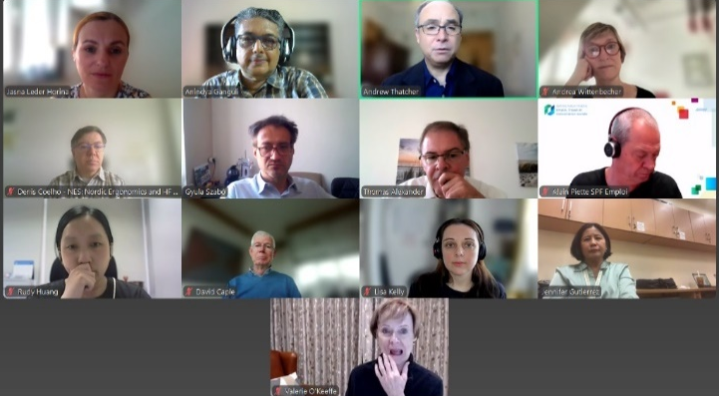
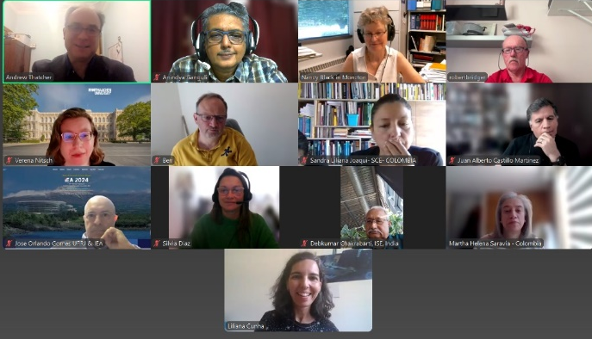
Notes by Nancy Black, VPSG@iea.cc (based on video recordings).

