Update report for IEA CPR standing committee
Presentation at Executive Committee - April 27th, 28th, Nottingham, England.

Prepared by Martin A. Rodriguez, IEA CPR Chair.

“It is about Dreaming, and young people are the IEA future”. Based on Andrew Thatcher´s words

The IEA aims:
● To develop more effective communication and collaboration with federated societies
● To communicate our IEA publications (and other communications) into multiple languages, especially to deal with geographical areas which are showing strong growth at the moment (especially China and South America).
● To develop interactions between Early Career Professionals

Guiding principles for IEA activities and goals (Seven Policies)
All activities of the CPR committee need to be aligned to the seven IEA policies:
1. Engage stakeholders
2. Collaborate with and reinforce IEA Networks
3. Contribute to science, technology, and practice
4. Identify the roles of IEA in promoting education, certification, and related matters
5. Reinforce relationships with external organizations (existing and new)
6. Reinforce the infrastructure of IEA
7. Maintain a future focus for HFE

Introduction and purpose of the committee
In light of this, the key strategic areas of focus for the CPR committee need to be:
1. Improved and diverse communication with and between internal and external stakeholder groups.
2. Promote and enhance the IEA’s presence on and use of social media platforms to promote events and activities of the IEA and its stakeholders to demonstrate the value add of the IEA and its internal stakeholders (federated societies, networks and committees).
a. Promote and share high quality research and practice of HFE through the IEA webinar program and promotion of technical committee, network or federated society events.
3. Enact and leverage the MOUs with external stakeholders through IEA executive liaisons

The CPR committee is responsible for the following as part of the broader IEA Executive:
To promote and create awareness of the IEA and ergonomics events, publications, activities, and opportunities on a global scale. This should be facilitated through the interaction with:
a. International and national organisations (external stakeholders)
b. The global public (external stakeholders)
c. University networks (external stakeholders)
d. Federated and affiliated societies of the IEA (internal stakeholders)
e. IEA Networks (internal stakeholders)
f. IEA Standing committees (internal stakeholders)
g. IEA Technical committees (internal stakeholders)

Co-chair listing:
Martin Rodriguez (CPR Chair);
Barry Kirby (Social media coordinator);
Marible Grazon Mejia (ECR and outreach coordinator);
Abigail Du Plessis (IEA NewsBriefs editor);
Paulo Antonio Oliveira (senior liaison with external stakeholders)

Summary plan for 2024-2027 term:
Project / initiative | How does this create value-added? | How does this align with IEA strategies policies? | What needs will be met? | Goals to be reached | Milestones (Outline to measure progress) | Current status  [to start /  in progress / completed]
1. Improve communication between internal and external stakeholders: Promotion activities/focus areas | Knowing IEA activities and strategies | Engage internal and external Stakeholders | Promotion of IEA Communications activities such webinars, etc. | Technical Committees Webinars support | On Schedule, organizing events | In progress
2. Promote and enhance the IEA’s presence on and use of social media platforms to promote events and activities of the IEA and its stakeholders. | Promoting events and activities of the IEA and its stakeholders to demonstrate the value add of the IEA and its internal stakeholders | Engage Stakeholders | Improve the presence and use of social media platforms of the IEA, including Linkedin, Facebook, Twitter, Tik Tok and Instagram; and mailing lists (through the News Briefs) to promote the IEA and its internal stakeholders. | New LinkedIn Account. New Instagram Account.  New Tik Tok Account | LinkedIn and Instagrams Accounts created and with publications every week. Tik Tok to be created. | In progress
3. Create an “Ergonomics Event Calendar” | Improving Communications in Social Media and web site | Engage Stakeholders | Interactions with IEA EC and Standing Committees | Developed | Developed | Done

1. Improve communication between internal and external stakeholders: Promotion activities/focus areas

Map of interactions of Stakeholders

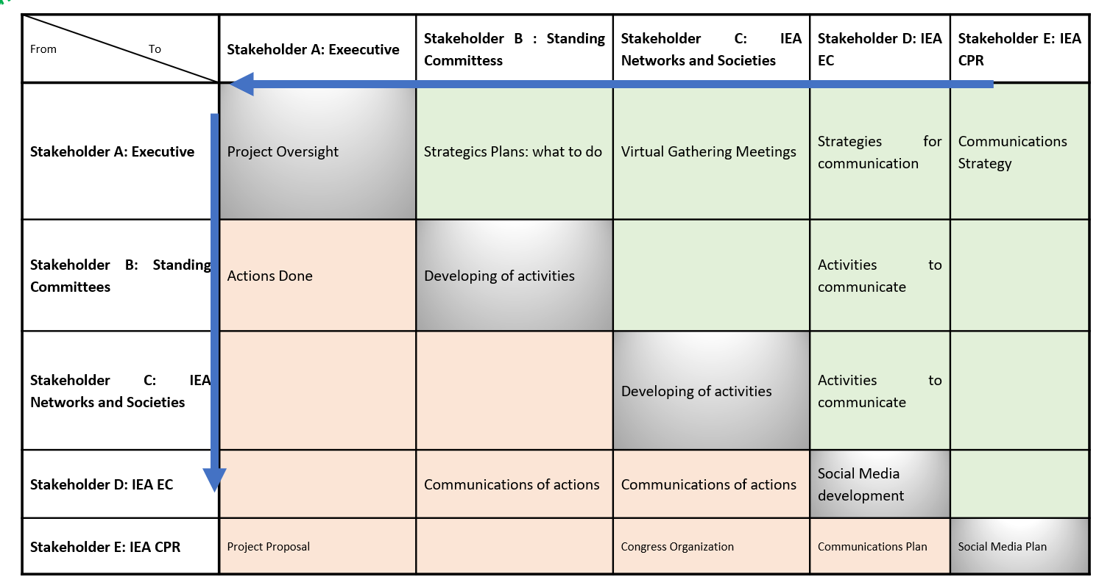

Benefits to stakeholders
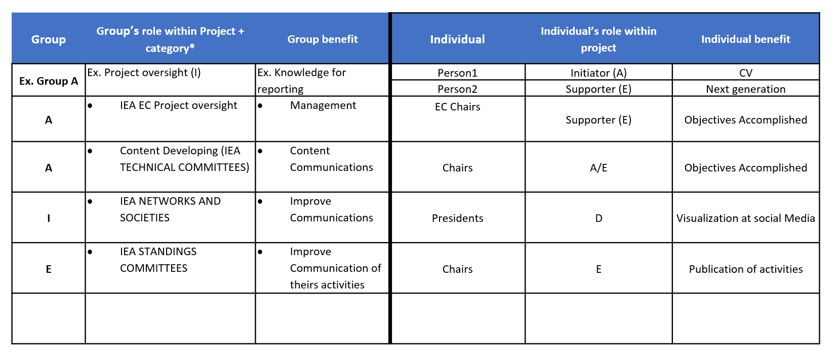

2. Promote and enhance the IEA’s presence on and use of social media platforms to promote events and activities of the IEA and its stakeholders.

Map of interactions of Stakeholders: IEA Social Media

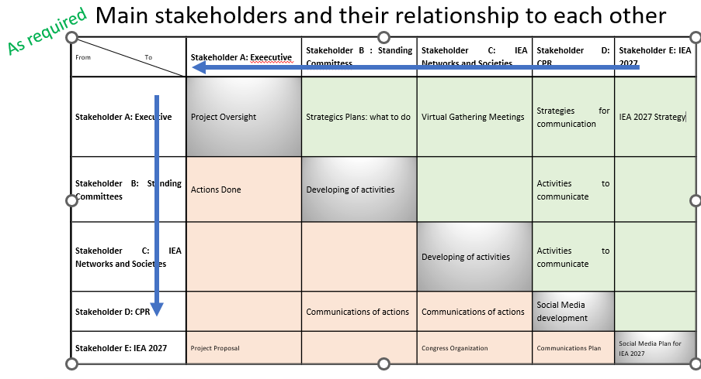

Benefits to stakeholders
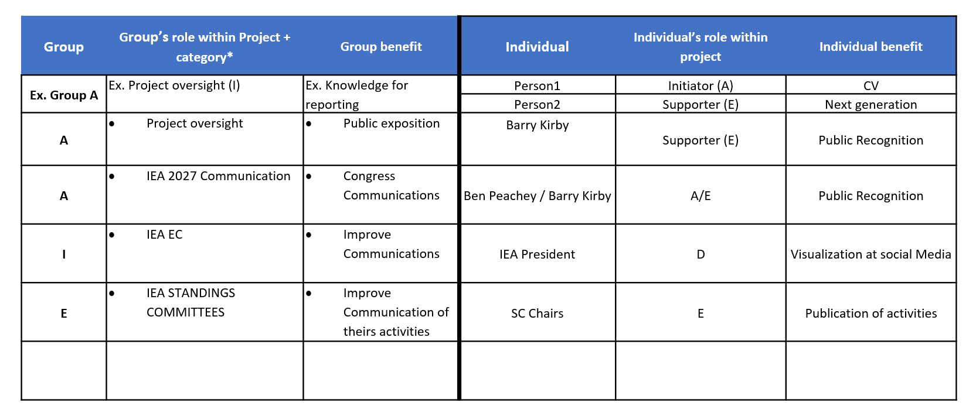
Activities and resources required
Activity undertaken | Societies/committees involved | Hours dedicated to activity | Resources used
IEA 2027 Communication issues | IEA 2027 Commiittee | To define | Social Media resources
Webinars organization | Standing Technical Committes | 8 | Web Resources

Future Activities

Mandatory: Develop a Professional Community Manager (Social Media) to manage all social media networks and new ones.

Opcional: Develop a professional graphics design individual to assist in the development of short videos, graphics and gifs for sharing on various social media platforms

