During the May 7th online gathering Andrew Thatcher (IEA president) focused on the recent SWOT analysis (strengths - weaknesses - opportunities - threats) facing the IEA and Verena Nitch, chair of PSE Professional Standards and Education (PSE) survey of IEA Member Societies completed last fall. Breakout groups considered three questions relating to those presentations. Responses to these questions are compiles across all break-out groups and the two sessions (0700 and 1600 UTC).
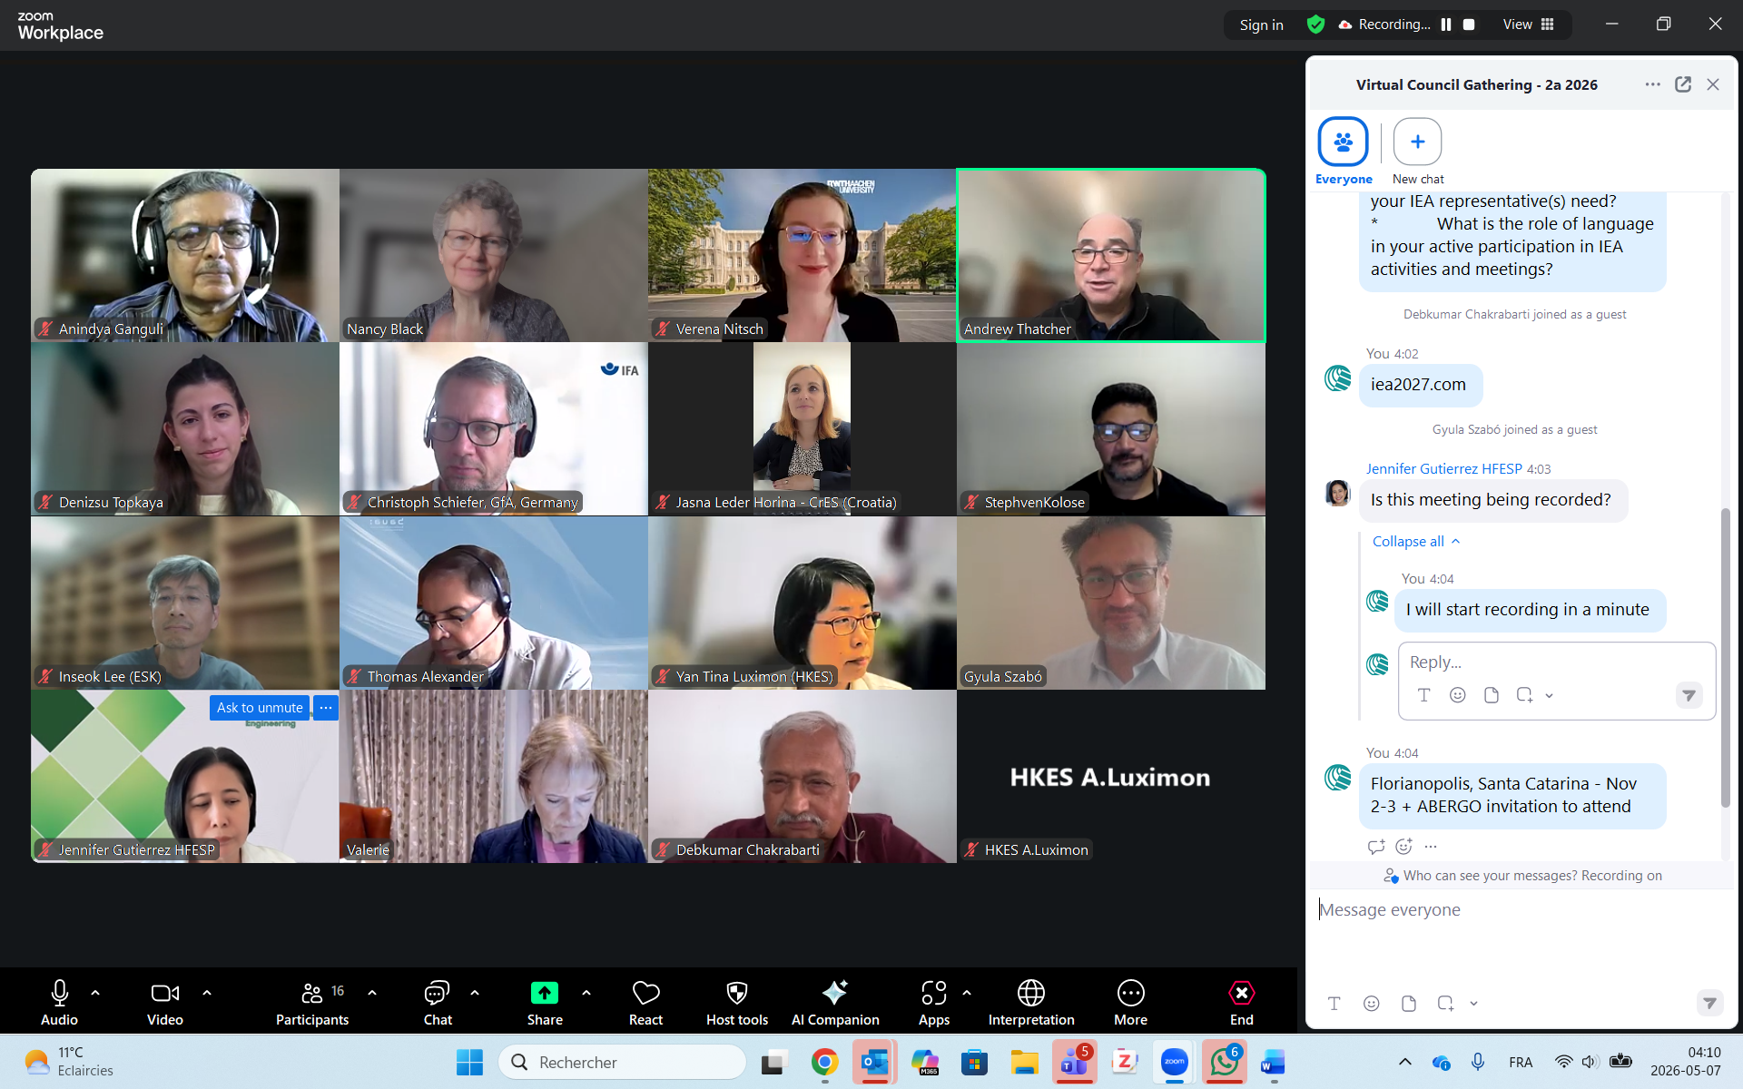
Participants

Anindya Ganguli (India)
Christoph Schiefer (Germany)
Debkumar Chakrabarti (India)
Gyula Szabo (Hungary)
Insoek Lee (Korea)
Jasna Leder Horina (Croatia)
Nancy Black (VPSG, Canada)
Thomas Aleksander (VP-T, Germany)
Valerie O’Keefe (Autralia)
Bob Bridger (UK)
Masaaki Mochimaru (Japan)
Silvia Diaz (Uruguay)
Tomasso (Italy)
Andrew Thatcher (President, South Africa)

Q1 - What information (On-boarding + as IEA representatives) is important for members?
Onboarding information should include a brief summary
- the aims and objectives of the IEA (the big picture)
- Role of council members (otherwise not well-defined and not clearly known)
- Roles and responsibilities of the EC members
- Reminder of where to find key support documents (ex. Past meeting minutes)
  - How to trouble-shoot (if unable to access member area)
Suggestions for better onboarding:
- Provide brief handout in several languages with information on IEA governance structure (e.g. what’s the difference between EC and Council members), how to vote, how many votes each society representative has
- Short on-boarding webinar for new Council members
- The guidelines should be very basic (short)
- Archives of earlier transactions should be available. NB – already all previous meetings minutes are available on the IEA.cc website in the Members area
  - Council members face technical difficulties in accessing the Council members area (if login is not functional; email not recognized)
- Remind representatives that they should brief the incoming person taking over
- Define an on-boarding process, particularly for new Council members.

Q2 - Does your group (Member society / Sustaining Member) have the capacity to share the information your IEA representative(s) need?
Reponses varied.
- GfA new member asked previous council members
- The CIEHF has a robust on-boarding system which can be a model (Bob)
CREE uses human support in the form of a tutoring process
- ESK uses personal on-boarding
- Transfer was not very smooth for some
Barriers to information flow from IEA to Societies and vice versa:
- IEA Newsbriefs content is often taken up in the society’s own newsletter, but these are infrequent (quarterly or even annually)
- Different societies choose council meeting representatives very differently: sometimes it’s the president/vice president or past-presidents, other times it’s a special representative who serve over a longer period of time, but these may not be as integrated into the society’s governance
- Better continuity in communication is provided by secretaries/functional email addresses that don’t change so frequently
To support networking:
- Distribute attendance list to attendees after meeting, preferably with contact details
- Introduce a buddy system for each council meeting (maybe with someone from similar language background) especially for new members
- Distribute handouts with key information
- A WhatsApp channel, allows monitoring of who reads the messages
- Measurements of the impact and outcomes (of the IEA documents) must be established

- Newsbriefs discussion (as a communication method)
  - information is disseminated to Federated Society as newsletter.
    - Italy distributes this message to all its member
    - Others filter content and put items of interest in Society’s newsletter
  - The Newsbriefs is too long, and so most people don't read it despite interesting and important content. Favour brevity, and clarity, particularly using headlines and links
  - The information disseminated through the Newsbriefs is appreciated, but changes are required in the content and structure of the Newsbriefs
- Other concerns raised:
  - To address one of the top concerns that emerged from the Federated Society survey (recruitment and retention of members), experience sharing between societies must be encouraged (Masaaki)
  - Domestic approaches to new technology (such as AI and Robotics) and the role of HFE should be shared among societies (Masaaki)

Q3 - What is the role of language in your active participation in IEA activities and meetings?
- Use software for translation (AI captions, translation of texts) – but check with native speakers for accuracy
- Even native English speakers speak with differing accents (ex. Australian and Canadian, British, …). Accents and pronunciation make it difficult to understand
- Captions / transcripts in different languages are required to allow full participation of all.
- Even other information available on the website and Newsbriefs should be in different languages (Insoek)
- RSS feed may be a solution - an RSS feed widget can be made available on the IEA website (Gyula). Add an "RSS feed widget" to your WordPress site and use https://iea.cc/feed/ and https://ergonomics-fees.eu/feed/
For example see the right slider https://met.ergonomiavilaga.hu/
- The use of AI should be explored. Technology solutions like AI translators may be used, but AI translation tool are not uniformly good (in all languages)
- Native speakers tend to speak too fast and should slow down

